**SRS DOCUMENTATION**

**PROJECT NAME: COMMISSION**

**VERSION: 1.4**

**PREPARED BY: SAJA LAHALIH**

**202109972**

**26/11/2023**

Contents

**1.**Introduction 3

1.1 Purpose 3

1.2 Scope 3

1.3 Document Conventions 3

1.4 Intended Audience 4

**2.**Overall Description 4

2.1 Product Perspective 4

2.2 Product Functions 4

2.3 User Classes and Characteristics 7

2.4 Operating Environment 7

2.5 User Documentation 8

2.5 Assumptions and Dependencies 8

**3.** System Features 9

3.1 Feature: Remaining Goods Calculation 9

3.2 Feature: Sailed Priority (First-in First-out) 9

3.3 Feature: Create Merchant New Account 9

3.4 Feature: Goods Sales Receipt Printing 10

3.5 Feature: Merchant review his goods 10

3.6 Feature: merchant communication 10

**4.** External Interface Requirements 11

4.1User Interfaces 11

4.2 Hardware Interfaces 19

4.3 Software Interfaces 20

4.4 Communication Interfaces 20

**5.** Non-functional Requirements 20

5.1 Performance Requirements 20

5.2 Security Requirements 22

5.3 Reliability and Availability 22

5.4 Maintainability 22

5.5 Portability 22

**6.** Other Requirement 23

6.1Legal and Regulatory Requirements 23

6.2 Other Requirements 23

# **1.**Introduction

1.1 Purpose

The goal of the Commission Management System (CMS) project is to make things better and easier for how commissions are calculated and managed in central markets in Palestine or even for businessman how do the same work. Right now, they use an old system, but we want to change that. We're planning to use a modern system that works on servers and helps people work together at the same time. We have a few main goals: make it easy for people to use, let them access it online so they can use it from anywhere. The CMS project wants to give central markets & businessman a strong and flexible solution that makes tracking commissions better, lets people access to their data easily, and helps the local markets and the business grow and compete better.

1.2 Scope

The scope of the CMS project includes the development and implementation of a Commission Management System. It involves functionalities such as commission calculation, remaining goods tracking, simultaneous user access, goods prioritization, data synchronization, report generation, goods entry, merchant account creation, goods review, and merchant communication, On the other hand it does not include the payment by the app and multiple languages than English and Arabic.

1.3 Document Conventions

|  |  |
| --- | --- |
| **Acronym** | **Definition** |
| API | Application Programming Interface |
| CMS | Commission Management System |
| CSS | Cascading Style Sheets |
| FIFO | First-in First-out |
| HTML | Hypertext Markup Language |
| HTTP | Hypertext Transfer Protocol |
| HTTPS | Hypertext Transfer Protocol Secure |
| IOS | iPhone operating system |
| JSON | JavaScript Object |
| OS | Operating System |
| XML | eXtensible Markup Language |

1.4 Intended Audience

1. Developers.
2. Project Managers.
3. Testers.
4. Designers
5. Stakeholders
6. MaintenanceTeams
7. Document Reviewers

____________________________________________________________

# **2.**Overall Description

2.1 Product Perspective

The CMS will interact with various components and systems make sure everything runs smoothly.

It consists of two main module which is computer, smart phone application to input data, customize commission settings, and generate reports.

The product basically will integrate with:

- central server: The CMS communicates with a central server for data storage and retrieval.

-Authentication Service**:** to register with Gmail accounts.

The CMS relies on internet connection for online access and server communication

2.2 Product Functions

Fig.2.1 shows the function flow chart. The function involved:

1. Commission Calculation

* **Description:** The system must calculate commissions based on a defined percentage of sales, the size, quantity, and market price of goods.
* **Goal**: Assume the calculation of commissions without mistakes.
* **Inputs:** Sales data, commission rates, good’s size or quantity
* **Outputs:** Calculated commission amount, the business profit and the Merchant’s profit.
* **Use case**: Actor: the central markets or businessman

On Monday merchant came and want to enter some goods and the central markets accept the goods and entered the percentage of sales, the size, quantity, and market price of goods to the system to calculate the commission percentage.

b. Simultaneous User Access

* **Description:** Multiple users can access and work on the system simultaneously.
* **Goal**: Increase the system users.
* **Inputs:** User authorization.
* **Outputs:** Concurrent access to the system for collaborating on tasks.

c. Data Synchronization

* **Description:** Changes made by one user must be synchronized in real-time for all users.
* **Inputs:** User make changing on data.
* **Outputs:** data changed on all the users.

d. Generate reports

* **Description:** generating reports for the manager, merchant, the center.
* **Goal:** Provide visions for the profits, commission percentages, items sold and remaining and additional relevant data.
* **Inputs:** number of profits for the merchant and commission percentage, goods sailed and extra data involve all the merchant’s data for the manager and the center.
* **Outputs:** report printed or pdf.
* **Use case:** Actor: the manager.

The manager logs into the system and navigates to the "Generate Reports" section.

Selects the type of report (e.g., profit report) from the available options.

Specifies the date range for the report and chooses specific merchants or goods types if needed.

Clicks on the "Generate" button to initiate the report generation process.

The system processes the request, retrieves relevant data, and displays the report in the console area.

The manager has options to download the report.

e. Enter goods

* **Description:** enter to the system the goods for each merchant
* **Goal:** collect information about the goods to enter it to the system so it become easy to deal with.
* **Inputs:** the size, quantity merchant’s goods and the date, type, id.
* **Outputs:** the data added to the system.
* **Use case:** Actor: The central markets or businessman

On Monday merchant came and want to enter some goods and the central markets accept the goods and entered the percentage of sales, the size, quantity, and market price of goods to the system.

f. Create merchant new account

* **Description:** enter to the system new account for the merchant
* **Goal**: Enter new merchant to the system.
* **Inputs:** name, goods type, id.
* **Outputs:** new account added to the system.
* **Use case:** Actor: The central markets or businessman

Merchant came to the central markets or businessman and wants to be included to the system so he can sail his goods and the central markets or businessman accept and press into new merchant button then enter the merchant information and press on button create and new merchant enter the system.

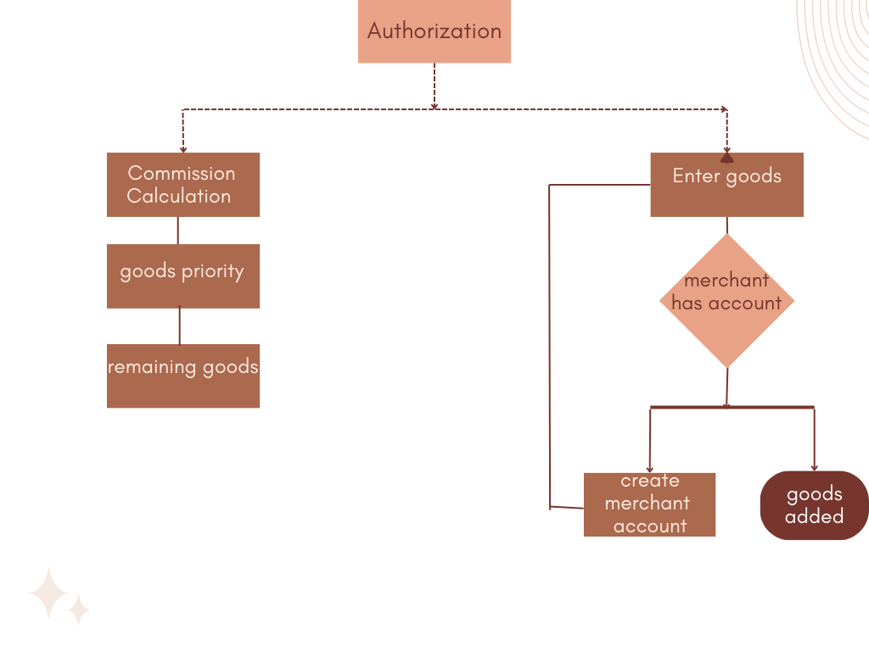

Fig.2.1: Functionality flow Chart

2.3 User Classes and Characteristics

|  |  |  |
| --- | --- | --- |
| *User* | *Class* | *Description* |
| Merchants | Primary Users | -Someone who bring goods and has an account.  - View information related to their goods and commission calculations.  - Ability to send massages to the manager to remove goods, inform him when bring goods |
| Managers | Management | -Wath and keep tracking everything in the system  - Create detailed reports. |
| System Users | Worker | -Who use the system for various purposes:  -Creating new merchant accounts  -Commission calculations  - Print a sales receipt for the merchant  -Enter the goods to the system and sail it  -Generate reports |

2.4 Operating Environment

To operate the system, we need these environments:

. Hardware environment –Server for data storage, Devices used by central markets, businessmen, and other stakeholders.

. Software environment-Fig 2.2 Shows software percentage uses at 2023

windows, Linux, IOS, macOS and Android.

. Network environment–Internet connection for server communication.

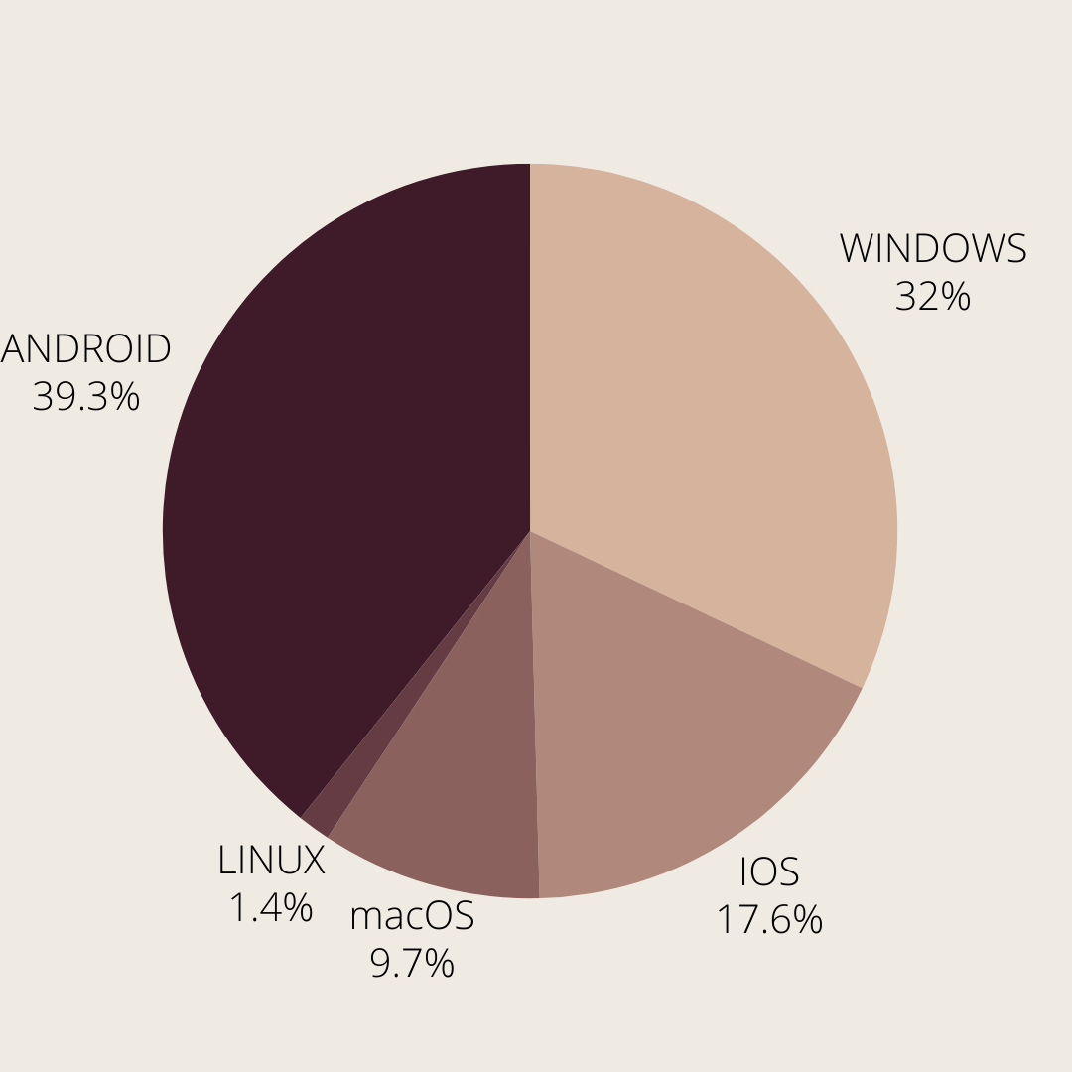

Fig 2.2 Software percentage uses 2023

2.5 User Documentation

We will create user manual to explain every stipe how the user will interact with the system also, we will provide a video to support this explanation.

2.5 Assumptions and Dependencies

- My assumptions for the goods that it involves any type e.g. (clothes, vegetables and fruits….)

- For the dependencies:

. The requirement for commission calculation depends on enter goods, sailed priority requirement

. Generate reports requirement depends on remaining goods

commission calculation requirement

________________________________________________________________________________________

**3.** System Features

3.1 Feature: Remaining Goods Calculation

. **Description**: Calculate how many goods sailed and how much goods remains.

**. Goal:** keep tracking how much goods remain so it can be entered to other function for priority calculation.

• **Inputs:** The Merchant’s ID, name, number of sailed goods.

• **Outputs:** The remaining quantity and for who belongs.

**.** **Use case**: Actor: the central markets or businessman.

* On Sunday someone came and want to buy some goods so the user search for the same goods with priority function and enter the information to calculate the commission and merchant profit and the goods that didn’t sailed entered to the system according to it brings date.

3.2 Feature: Sailed Priority (First-in First-out)

. **Description**: Put the latest goods in higher priority to sail it faster so it didn’t damage.

**. Goal:** Prevent the goods damage.

• **Inputs:** good’s entered date.

• **Outputs:** which good have the priority to sail (Its ID and the owner).

**.** **Use case**: Actor: the central markets or businessman

* On Tuesday merchant came and want to enter the goods and another one came last night to enter his goods so the system user put the last night goods in higher priority than the one who came tonight.

3.3 Feature: Create Merchant New Account

. **Description**: create a new account for a merchant into the system.

**. Goal:** Enter new merchant to the system.

**.** **Use case**: Actor: The central markets or businessman

* Merchant came to the central markets or businessman and wants to be included to the system so he can sail his goods and the central markets or businessman accept and press into new merchant button then enter the merchant information and press on button create and new merchant enter the system.

3.4 Feature: Goods Sales Receipt Printing

. **Description**: Generate and print sales receipts for merchants include successful goods sale transactions.

**. Goal:** Provide hard copy for merchants.

**.** **Use case**: Actor: The central markets or businessman

* Merchant came to the central markets or businessman he wants to take his profit so the central markets or businessman opens his account and print to him the information.

3.5 Feature: Merchant review his goods

. **Description**: View the goods the sailed and remaining one, his profit.

**. Goal:** Provide interface for the merchant to review his goods.

• **Inputs:** goods type, remaining or sailed goods.

• **Outputs:** list of information about goods.

**.** **Use case**: Actor: The merchant

* Merchant opens his account and click on sailed goods then he see a list of the sailed goods his and profit.

3.6 Feature: merchant communication

. **Description**: Communication way between the merchant and the manager.

**. Goal:** Facilitate the communication between the merchant and the manager.

• **Inputs**: text massage.

• **Outputs:** massage send.

**.** **Use case**: Actor: The merchant

* Merchant opens his account and click on communicate button then he displays text massage and send it to the manager.

**4.** External Interface Requirements

4.1User Interfaces

4.1.1 Login Interface:

Fig.4.1.1 shows log in interface.

**Components:**

* Labels for Username and Password.
* Text fields for users to enter their username and password.
* Log in button to submit the entered information.
* Forgot Password link to enter the email connected with the system for account verification and password change.
* Link for create new account.

4.1.2 The main interface:

Fig.4.1.2 Shows main in interface. **After Successful Login:**

* Provides an overview of key information.
* Button for quick access to major functions.

4.1.3 Commission Calculation Interface:

Fig.4.3 shows calculation interface.

**Components:**

. Input fields for sales data, commission rates default value 10%,

. Combo box for merchant name and goods type.

. Input fields for goods' weight or quantity.

. Calculation results display commission amount, and merchant's profit.

. calculation button.

. At the same time, it calculates the remaining goods from this type and save it.

4.1.4 Priority Interface:

Fig.4.1.4 shows priority interface. Users interact with this interface to view and manage the priority order for selling goods based on the FIFO principle.

**Components:**

* Combo box for the users entering good`s type, merchant name.
* Interface includes a button that displays goods selected by type according to their priority.

4.1.5 Remaining Goods Interface:

Fig.4.1.5. Shows remaining goods interface.

**Components:**

* When users sell goods, the system subtracts the sailed quantity.
* Interface includes a label for good`s type
* Combo box to select the type.
* button that displays goods in the system according to their type for reports, checking if there are goods to sell.
* Label to print the remaining goods.

4.1.6 Generate Reports Interface:

Fig.4.1.6. shows generate report interface. Allows users to generate and view various reports related to profits, commission percentages, remaining goods, and other relevant data.

**Components:**

* Labels and options for selecting the type of report to be generated (e.g., profit report, commission percentage report, goods remaining report).
* dropdowns for specifying parameters such as good`s type, specific merchants, start date to generate, or any other relevant filtering criteria. Console for display or download options for generated reports.
* An area to display the generated report
* Button for generate the reports.
* Button for download the reports.
* Button for printing the reports.

4.1.7 Enter Goods Interface:

Fig.4.1.7. Shows enter goods interface. When a merchant wants to enter goods and the central markets accept the goods

**Components:**

* Text fields for goods data- good quantity by number or weight, and the current date.
* Combo box for - merchant name, good`s type.
* Text fields for add new type.
* Button for submitting and saving the data.
* Confirmation message or error display after data entry.

4.1.8 Create Merchant New Account Interface:

Fig.4.1.8. Shows create merchant new account interface. This interface is used for creating new accounts for merchants who are joining the system.

* **Components:**
  + Form for entering merchant details such as name, email, password.
  + Sign up button.
  + Button to go back to log in page.
  + Confirmation message for successful account creation.

4.1.9 Merchant review his goods interface:

Fig.4.1.9. showcases the merchant review interface allowing a comprehensive overview of sales and remaining goods.

**Components:**

* Combo box for - good`s type, remaining or sailed goods.
* Button for view the whole profit.
* Button for view the selected information.
* Console to display the information.
* Button to filter and clear what been selected.

4.1.10 merchant communication interface:

Fig.4.1.10introduces the communication interface, interaction between the merchant and the manager.

**Components:**

* A label such as "Message" indicating where the merchant can input their message.
* Send Button.
* Notification Alerts showing the merchant that the message sends successfully.

Top of Form**FUNCTIONS INTERFACES**

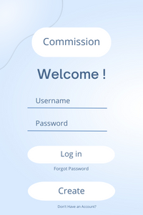

Fig.4.1.1 Log in interface Fig.4.1.2 Main in interface

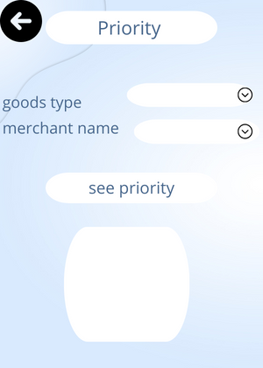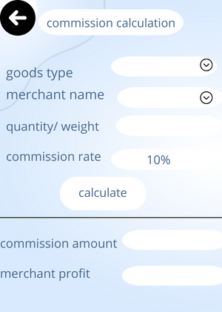

Fig.4.1.3. calculation interface. Fig.4.1.4. priority interface.

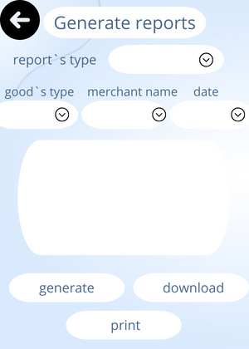

Fig.4.1.5. Remaining goods Fig.4.1.6. Generate report

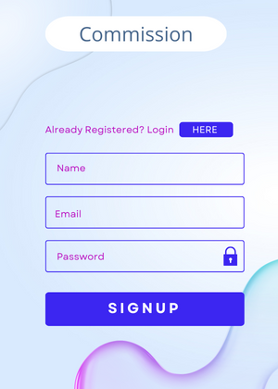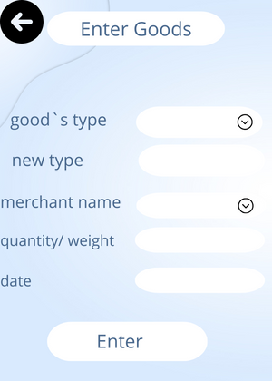

Fig.4.1.7. Enter goods Fig.4.1.8. Create merchant new account

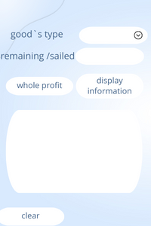 

Fig.4.1.9. View goods Fig.4.1.10. Communication

4.2 Hardware Interfaces

Fig.4.2.1 Showes Hardware diagram

4.2.1 Server

The CMS interact with central server to store data and brings it

Key interaction

* **Data Storage:** Store data, commission merchants, goods

and user information on the server.

* **Data Retrieval:** Retrieving relevant data from the server during commission calculations, report generation, and other operations.

4.2.2 Central Markets and Businessmen devices:

The devise her is computer, laptop.

Key Interactions:

* **Web Interface:** Users interact with the CMS through web interfaces on their devices.
* **Data Entry:** Inputting information about goods, commission and other data using devices.

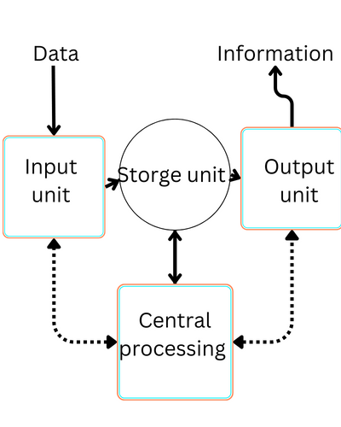 Fig.4.2.1. Hardware diagram

4.3 Software Interfaces

The CMS provides a web interface for users to interact with the system. This interface allows users to input data, customize commission rules, authorization, and generate reports.

* API forms for data entry, HTTP/HTTPS requests.
* API user authorization, JSON or XML for sending user credentials and receiving authentication tokens.

- API calls to send notifications to user devices, JSON or XML for delivering notification content.

-Browser Interface: Users access the CMS through web interfaces using various browsers (Chrome, Firefox, Safari) build with HTML, CSS, and JavaScript, HTTP requests and responses with HTML, CSS, and JSON data.

4.4 Communication Interfaces

This project supports all types of web browsers.

Communication ways:

. Email

. The system it self

. Application notifications

_______________________________________________________________________________

**5.** Non-functional Requirements

5.1 Performance Requirements

5.1.1 Response Time:

Fig.5.1 show response time for log in prosses.

* + The system should respond to user inputs within 2 seconds for the operations, such as commission calculation and goods entry.
  + Report generation, involving calculations, should be completed within 5 seconds.

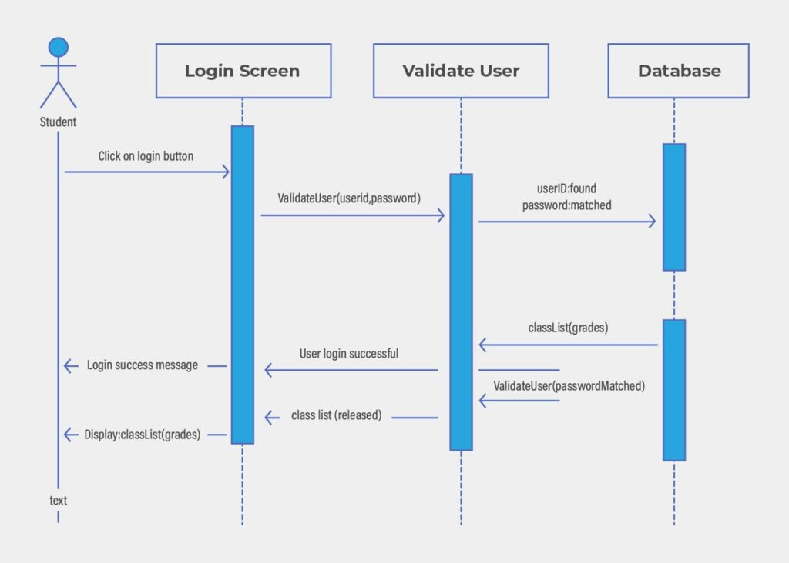

Fig.5.1 log in

5.1.2 Concurrent User Handling:

* + The CMS should support a minimum of 20 concurrent users performing various tasks at the same time.

5.1.3 Data Synchronization:

. Changes made by one user should be edited in real-time for all users within 500 ms.

5.1.4 Data Storage and Retrieval:

Fig.4.2.1 Sows Data Storage. The system should be able to store and retrieve large volumes of data efficiently.

5.1.5 Throughput

. The system should to handle at least 100 transactions per second to make sure it processes user requests and data transactions quickly and efficiently.

5.2 Security Requirements

. Ensuring strong authentication mechanisms to verify the identity of users

. Encrypting data to prevents unauthorized interception of data during transmission and protects stored data from being accessed by unauthorized parties.

5.3 Reliability and Availability

The CMS shall have a Mean Time Between Failures of at least 10,000 hours.

5.3.1 Backup and Recovery

. Auto backups of the system data should be performed daily, with a backup retention period of at least one month.

5.3.2 Error Handling

. the system must handle the errors happened in entered wrong calculations such as enter the quantity of the goods while the goods must be entered by weight

5.4 Maintainability

Component Independence:

* System components should be designed to be independent of each other, allowing for updates without affect the entire system or other component.
* Also, the component shall have the minimum dependence on another.
* Component failed should not mean system down.

5.5 Portability

- Application Portability:

Supported Browsers: Chrome, Firefox, Safari.

Supported Devices: iOS, Android devices.

Supported Operating Systems: Windows, Linux, macOS.

**6.** Other Requirement

6.1Legal and Regulatory Requirements

6.1.1 Compliance with Data Protection Laws

The CMS must comply with relevant data protection laws and regulations, ensuring the privacy and security of user data. This includes

6.1.2 Local Business Regulations

Like tax regulations

6.2 Other Requirements

Offline Functionality

The CMS should provide limited offline functionality to allow users to access certain critical features even when not connected to the internet. This might include the ability to view previously entered data, access certain reports, and perform essential tasks without an active internet connection. Any data entered offline should synchronize with the central server once the connection is re-established.